CURRICULUM VITAE
SAHIL SHARMA
Address:-H.No. 763/19, Nr. Raghunath Mandir P Prem Nagar, Pathankot.
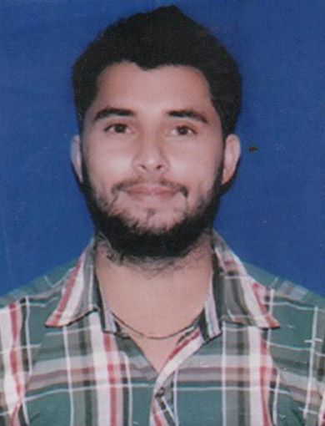
Teh &Distt:-Pathankot
State: - Punjab
Mobile:-9780761660
E-Mail Id: -India9258@Gmail.Com

CAREER OBJECTIVE:-

To work in a progressive work culture, that will serve a platform to learn and enhance my skills & where my knowledge and experience can be shared & enriched.

ACADEMIC DETAIL:-

* B.Tech (Mechanical) from Beant College of Engineering and Technology, Gurdaspur (Affiliated To PTU
Jalandhar) in 2013.

* 10+2(Non Medical) From Arya Boys Sr. Sec. School Pathankot, Affiliated to P.S.E.B Mohali, In 2009

* Matriculation From S.V.M Gho Pathankot, Affiliated To P.S.E.B Mohali, In 2007.

WORK EXPERIENCE:-

AUG 2013–TILL DATE: - Working As “QUALITY CONTROL INCHARGE” in UNIQUE INDUSTRIES, JAMMU.

JOB PROFILE: Quality Control Incharge & Production Engineer.

Key Responsibility Areas:-

- Testing the quality of PVC Conduit Pipes before dispatch according to the BIS (Bureau Of Indian Standard) Rules.
- Measurement of pipe dimensions to ensure compliance with specification.
- Marking of pipes with grade and acceptance-rejection status.
- Documentation, Filing and maintaining proper inspection Record and Sale Record according to the BIS Rule.
- Cut, Fit and welding metal components, including plate, structural shapes and pipe.
- Applying all tests like Checking dimensions, Bending Test, Compression Test, Impact test, Collapse test, Resistance to heat, Resistance to burning, Electrical Characteristics and insulation resistance etc..
- Maintain The Data Of Daily Input And Output Of Manufacturing Product.

SHORT TERM TRAINING AND PROJECTS (Academic):-

FINAL PROJECT: -Hydraulic Based Robotic Arm.

TRAINING:-

- 6 Weeks In-House Training at Beant College of Engineering and Technology, Gurdaspur.
- 6 Weeks Industrial Training at International Tractor Ltd. Sonalika, Hoshiarpur.
- 6 Months Industrial Training (From July 2012) At ITL (International Tractor Ltd.) Sonalika, Hoshiarpur.

EXTRA -CURRICULAR ACTIVITIES/OTHER ACHIEVEMENTS

- Worked as Senior Executive with Society of Mechanical Engineers.
- Active members of NSS.
- Member of ISTE (Indian Society of Technical Education).

PERSONAL INFORMATION

DATE OF BIRTH : 15 June 1991
GENDER : Male
NATIONALITY : Indian
EMAIL ID : India9258@Gmail.Com
PERMANENT ADRESS : H.No.763/19, Nr. Raghunath Mandir, Prem Nagar, Pathankot.
CONTACT : 9780761660
LANGUAGES KNOWN : English, Hindi, Punjabi.

DECLARATION

I hereby declare that the information furnished above is true to the best of my knowledge & belief and I will work similar to the manner in which a mechanical engineering professional is supposed to.

SAHIL SHARMA

